**OSINT exercise #006 (Gralhix)**

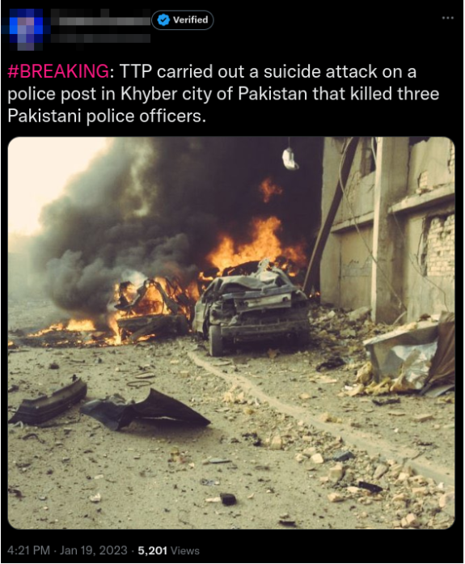

In this exercise, the tweet allegedly does not match with the attached photo. First, I Google reverse image search the photo to see if I can find the actual source for that photo. When I click on ‘exact matches’ I find several instances of the photo, dating back to 2014. I also find the post on Twitter/X with this photo. I also find a Wikipedia page of this photo, with the title: ‘WaziriyaAutobombeIrak.jpg’. I tried to look at the page of 2014, from far-rightmap.balkaninsight.com, but this page no longer seems to be active. The page is also not archived on the Wayback Machine. Looking at the Wikipedia page, I actually find a detailed description, a source and a date of 27 August 2006, which is way before 2014 and more importantly way before 2023. According to the Wikipedia page, the photo was taken in Baghdad, Iraq. All this information confirms that this picture indeed does not describe the event that the Tweet describes.